Viking Diary by Niamh
Dear diary,
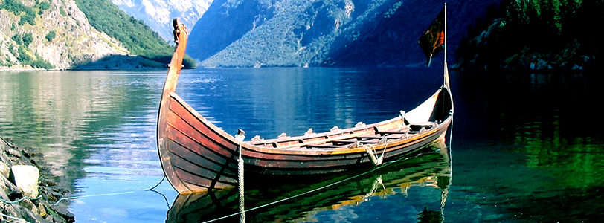
Today was the stormiest, coldest, windiest and choppiest day in the longboat. Everyone on the vessel was chattering with their teeth; the craft was rising up and down and everyone was sliding each end like the boat was tipping upside down. Everyone was squished because there wasn’t a lot of room. We all were scared and frightened.

The people on the boat with me were all getting ready for the big battle in Jorvik tomorrow. For tea we had dead fish from the sea that our fishermen fished out and the fish was gigantic so we all can have some and share. We gave the skinniest people who haven’t had much food in days the biggest bit and the fatter people who hogged most of the food have a microscopic bit off food. We were all ready for the next day of battle. We don’t like sleeping in the boat because it’s hard on the floor and it goes up and down in the night. It’s really cold so you have to have so many blankets. We all slept terribly but the next day came and we all went and sailed to Jorvik 2 hours away from where we were going but it felt like it was 1 hour because we were in a boat.
I have a couple of things that I don’t like about going to battle but I’m only going to tell you one: I always miss my friends and family.

By Niamh

