Geography
A collection of Port facts

Port
What is the definition of a port? A harbour where ships load and unload.
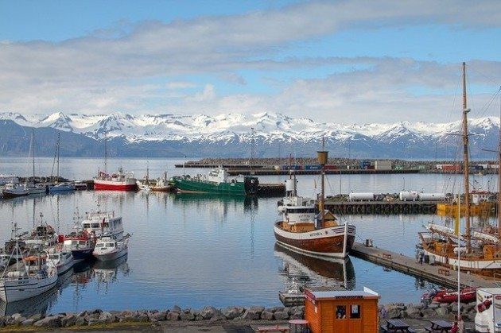
A port is a place where boats can come and go to load and unload their supplies/people. Ports are usually found in a city or town that has access to a harbour. In ancient civilisations, ports were the main mode of long-distance travel and trade.

What is the origin of the word port
The word port comes from the Latin word “portus” which meant “entrance”.

Different types of ports
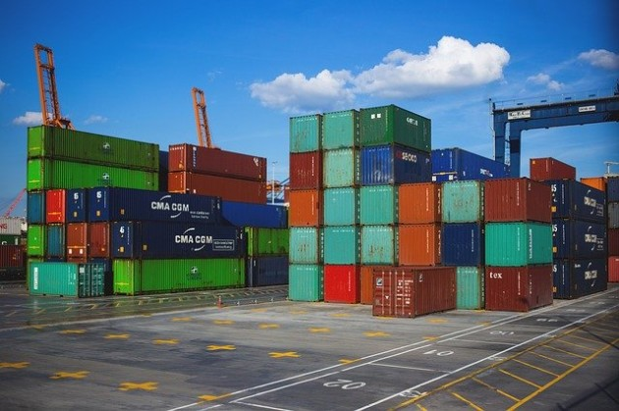
Dry Port
These are inland terminals that are connected to a road by the sea. They are used to transfer cargo to ships and store the cargo containers before shipping.

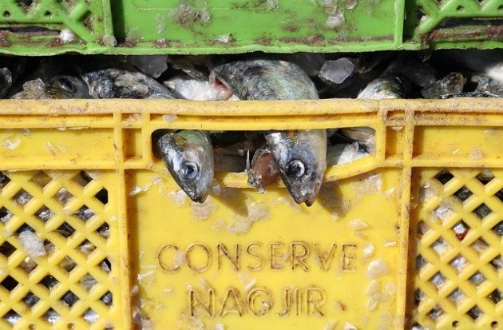
Fishing Port
These ports are for distributing fish. These are usually commercial ports that rely on the sale of fish to continue running.
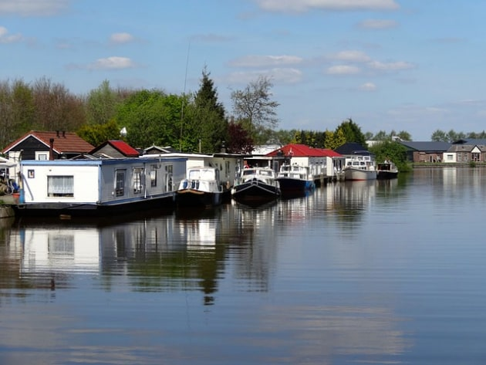
Inland Port
An inland port is located along a river, lake, or canal that has access to the sea or ocean.

Seaports
This is an umbrella term that covers ports that are connected to the sea or ocean.
Subtypes of this kind of port include:
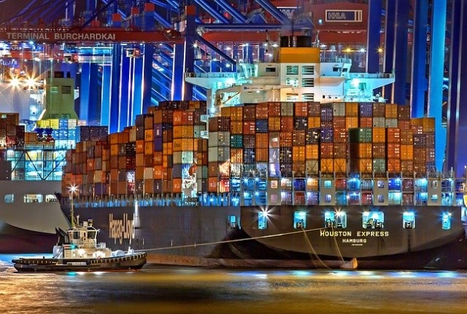
Cargo port
A port where cargo and shipping containers are on and offloaded. These ports usually have cargo containers in storage and large machines and trucks that are used to transfer the cargo containers to the trucks

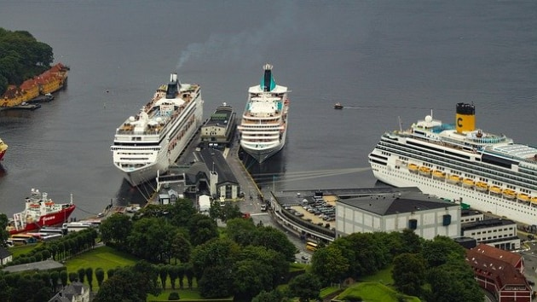
Cruise home port
This is where cruise ship passengers will board and disembark cruise ships. These ports are often clean and streamlined for people to easily access.

Smart port
These are automated ports that use artificial intelligence and cloud-based software to handle goods. This type of port increases the efficiency of delivering and moving products, while also decreasing any work-based injuries by using robots and automated machines.

Port of call
These types of ports are quick stops for ships to pick up supplies, such as food or fuel. This is also where cruise ships will stop to let their passengers off for a few hours.
Warm Water Port
Warm water ports don’t freeze over in the wintertime and are available year-long. Some of these include Vostochny Port in China, and Odessa in Ukraine.

UK port facts
There are about 120 commercial ports in the UK; These include all-purpose ports such as London and Liverpool; ferry ports such as Dover; container ports, such as Felixstowe, and ports catering for specialised bulk traffic, like coal or oil such as Immingham;
The UK ports industry handles 95% of UK imports and exports;
Every year, 65 million passengers and 500 million tonnes of cargo move through UK ports. British ports keep the economy moving.

