Homophones practice week 9
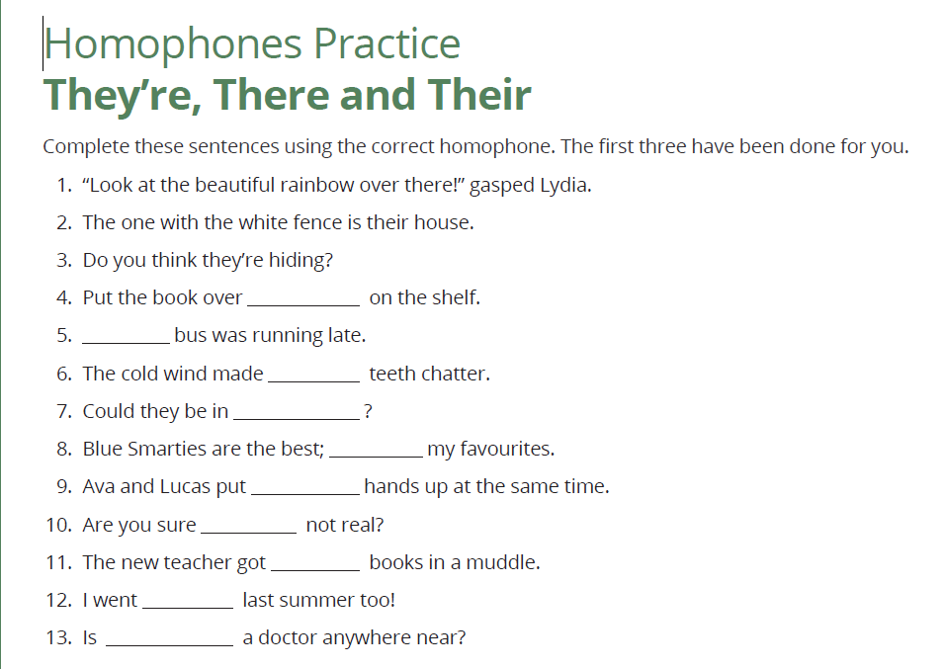
Now write three of your own to show you know their,,they’re ,there,

