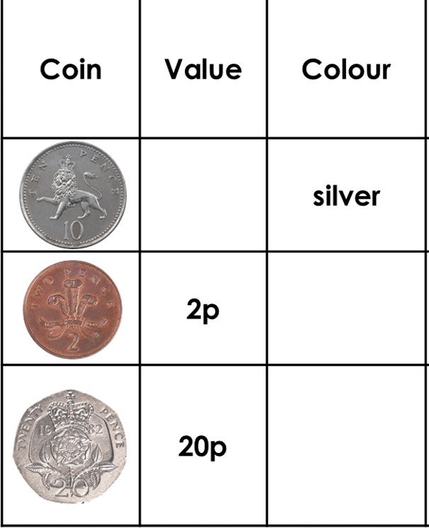
Can you complete the table and then add the remaining coins? You will need to draw each coin, write down its value and the colour of the coin.

Coin | Value | Colour

