Maths Year One Week 5:
Monday 29th June 2020 – Recognising and naming coins
Introduction | Main | Plenary
Oral starter:  Count out loud in;  - 1’s to 50  - 2’s to 20  - 5’s to 100  - 10’s to 100  This week we are going to be exploring the topic of money! There are lots of different ways to pay with money, coins, cards, phones etc. This week we are going to focus on learning how much each coin is worth, ordering them, adding with coins and working out how to give change…..what a busy week!  Key Vocab: Can you go through these words with your grown up  Coins, value, pound, pence, pennies, amount, total,  Have a look at the picture below (see attachment for larger image). Can you try and name each coin?  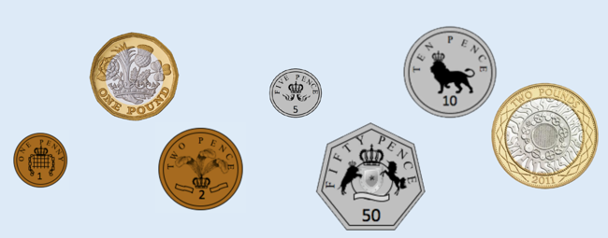  Did you correctly name them all? Remember some of these coins are pence (p) and some are pounds (£).  Can you create two groups and put all the pence coins in one group and all the pound coins in the other? | Think about the following questions and discuss them with a partner.  - All coins are round  - Can you find the odd one out?  1p, 5p, 6p, 50p  - The bigger the coin the more it is worth  Complete the main activity sheet for Monday – can you complete the table and then add the information for the remaining coins? | Yes/No Game:  In pairs can you take it in turns to choose a coin (but don’t let your partner see it!). The person without the coin has to ask questions to try and work out which coin their partner has chosen but you can only answer the questions with “yes” or “no”. Some example questions might include;  - Is your coin silver?  - Is your coin worth more than 5p?  - Is your coin a big or small size?  Coin Rubbing:  If you have some real coins and some wax crayons you could put the coins under a piece of plain paper and rub the wax crayon over the coin to make a coin picture!

Tuesday 30th June 2020 – Ordering coins and understanding their value
Introduction | Main | Plenary
Oral starter:  Count out loud in;  - 1’s to 50  - 2’s to 20  - 5’s to 100  - 10’s to 100  Today we are going to do some work on ordering coins. We can order coins in different ways – from the lowest value to the highest or from the highest to the lowest.  We can also say a coin has the most value. This means it is worth the most. A coin that isn’t worth much has the least value.  Try ordering these coins below. (Attached is bigger version)  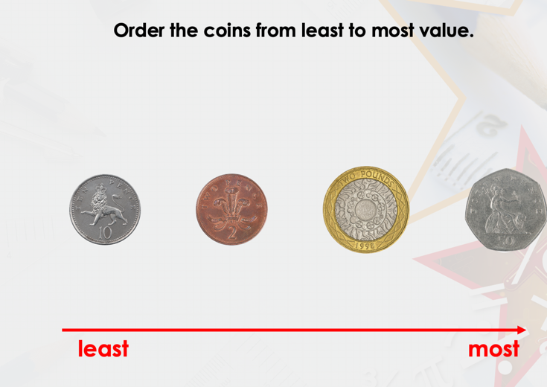  Can you put all the coins in order from least value to most value? | We now need to think about how the coins relate to each other.  Do you know how many pennies are in a pound? Tell a partner / friend / family member.  We can also make different amounts in different ways. For example, we can represent 10p with one 10p piece or with two 5p coins. Can you draw and show the following amounts;  - 50p in 5p coins  - 50p in 10p coins  - 40p in 10p coins  - 10p in 1p coins  - 20p in 2p coins  - 15p in 5p coins  - £1 in 50p coins  Can you now complete the main sheet and find the groups which show the same value of money but in different ways? | Can you choose some items from around your house or on your desk and decide how much each item is worth? Can you order all your items from least to most value or most to least?  In your Abacus Workbook 3 can you complete page 5 please.
Wednesday 1st July 2020 –Comparing coins by using the terms more than, less than or equal to (> < =)
Introduction | Main | Plenary
Oral starter:  Count out loud in;  - 1’s to 50  - 2’s to 20  - 5’s to 100  - 10’s to 100  Today we are going to continue counting with coins and also comparing amounts of money.  Can you discuss the terms with a partner or family member  - More than / greater than >  - Less than <  - Equal to =  In your Abacus Workbook 3 can you complete pages 23 and 24 please. | Activity 1)  Using the sheet can you add up the coins and write down how much there is altogether for the 1p’s, 2p’s, 5p’s and 10p’s.  Activity 2)  Can you label each group of coins using the vocabulary greater than, less than or equal to?  Can you then do the same using the symbols > < or = | With a grown up or a friend can you use the symbol flashcards and some coins. One person will pick up two coins and put one in each hand. The other person will find the correct symbol to make a number sentence.  Then swap over jobs.  To make it harder when picking coins you could have more than one in each hand/group.  For example, Miss Layton had a 10p, a 1p, and a 2p in one hand and a 20p in the other. Mrs Beavis added up the first hand (10p+2p+1p=13p) and looked at the 20p in the other hand.  We know that 20p has a higher value than 13p so Mrs Beavis made the number sentence 20p > 13p. She could have done 13p < 20p to show that 13p has a lower value than 20p.

Thursday 2nd July 2020: Money
Introduction | Main | Plenary
This week we have been learning about money.  Can you recap the value of coins from 1p to £2  Can you order the coins from smallest to largest in value? Perhaps you could use real coins to order them.  Now complete the coin detective worksheet – you will need different coloured pencils. You will 10p and some coins to use for change. Perhaps someone can be the shop keeper and the other person can be the customer. You will need to label some items under 10p – could you price some toys or kitchen items? If you pay with your 10p but the items is less you will need to get change. The apple I have chosen is 8p. I’m going to pay with my 10p how much change will I need? Remember to count on from 8p … 9p .. 10p = So you’ll need 10p. You can use your fingers whilst you count on.  My chocolate bar cost 5p. I pay with 10p. How much change will I get? 5p | Using your abacus workbook 3 can you complete pages 48-49 if you haven’t already.  Complete the change from 10p worksheet. | Word Problem Challenges:  How a toy and an empty price labels. I paid for this toy with 20p (show the coin). I got this amount in change. Show the class a 5p coin. Can you tell me how much the toy was? Give children a minute to discuss this with their partners then take feedback. Demonstrate that 15p + 5p = 20p so the toy must have been 15p. Write 15p on the price label. Show children 2p change and tell them you bought another toy with a 20p and got the 2p change. How much was the toy?

Friday 26th June 2020: Giving change from 20p
Introduction | Main | Plenary
This week we have focused on money and giving change. Today we will be learning how to give change from 20p.  Recap giving change from 10p. Remember to count on from your item price. The sunglasses cost 9p. How much change would I get?  The bottle of water cost 2p. How much change would I get?  Now let’s try giving change from 20p. The ice cream cost 12p. How much change would I get? The pencil case cost 18p How much change would I get? | Complete the change from 20p worksheet.  Complete the mastery worksheet. | Play the change board game. You will need a coin to play this game.

